Steps to setup MySQL database and link it to the source code (main.py)

1. Download XAMPP and MySQL Workbench
2. Start MySQL 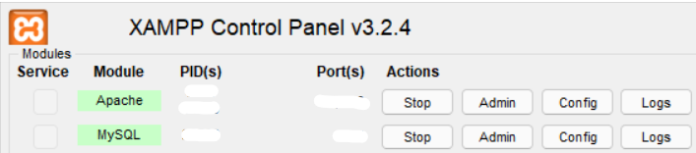
3. Create 3 tables on MySQL Workbench
4. Set names/price/description on Workbench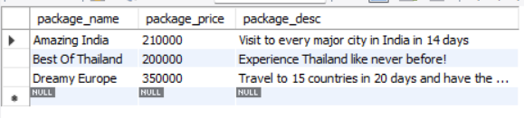

-Reyansh Gupta

Github.com/reyanshgupta